EXAMY 4
EXAMINATION COUCH, HEIGHT ADJUSTABLE
EXAMY 4 is designed for use in physical examination clinics, private clinics, ultrasound rooms, physiotherapy centers, and hospitals. With smooth electric movement, comfortable upholstery, and excellent stability, each element of the EXAMY 4 couch is crafted to enhance convenience for doctors. This versatile auscultation couch can adapt to various types of examinations, with multiple options and accessories available.
- Three sectional ergonomic design
- Easy to operate
- Backrest adjustment with gas spring
- Legrest adjustment by gas spring
- Electrical height adjustment
- Hydraulic height adjustment two sided foot pedals (optional)
- Hand remote control
- Foot control switch (optional)
- Retractable rolling system fixing floor on 4 rubber caps
- Epoxy painted steel frame
- High quality foam with synthetic leather coated
- 220 kg safe working load
- Foldable, chrome plated side rails (optional)
- Breathing space with plug (optional)
- Paper roll holder (optional)
- Battery Back-up (optional)
 | TECHNICAL DETAILS
 | Length | : 1900 mm
 | Width | : 700 mm
 | Height Range (electrical) | : 500 – 880 mm
 | Height Range (hydraulic) | : 500 – 950 mm
 | Castor Diameter | : 50 mm
 | Backrest Angle | : +85° / -30°
 | Legrest Angle | : +85° / -30°
 | Backrest Dimension | : 700 x 650 mm
 | Seat Dimension | : 700 x 1250 mm
 | Total Lying Surface | : 700 x 1900 mm
 | Safe Working Load | : 220 kg

OPTIONAL ACCESSORIES
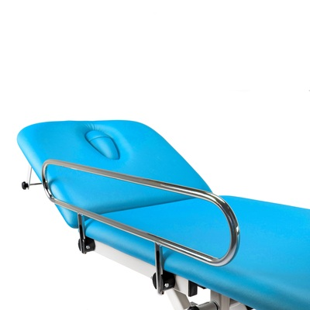
Side Rails
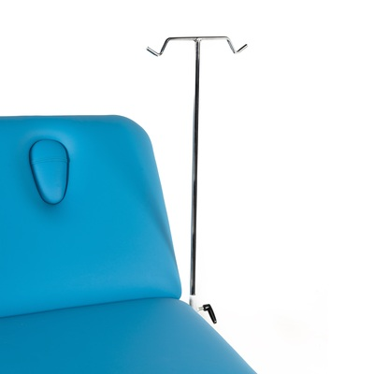
IV Pole
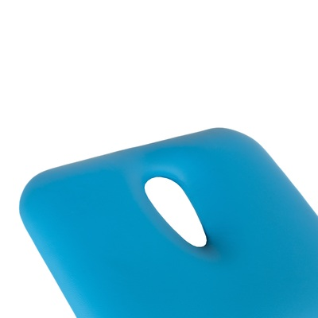
Breathing Hole with Plug
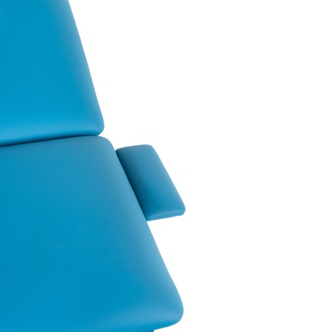
Armrest
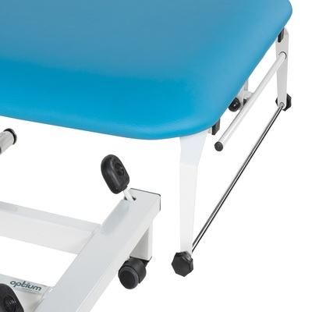
Paper Roll Holder
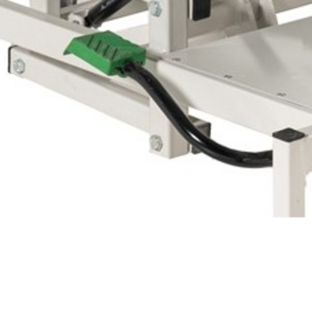
Hydraulic Height Adjustment
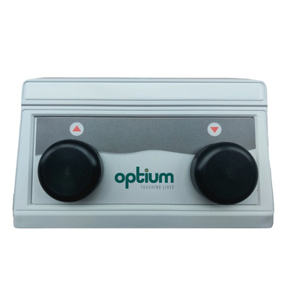
Foot Switch
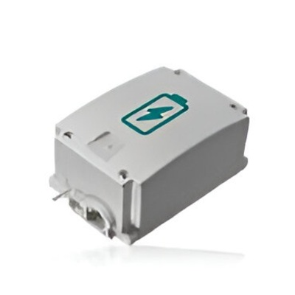
Battery Back-up
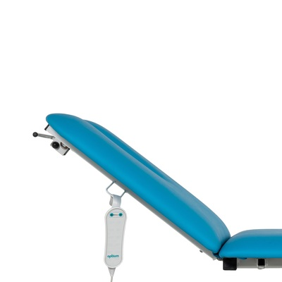
Electrical backrest/legrest
COLOR CHART
